Job Description and Person Specification
Job Title: Process Manager |  | Department: Technical
Location: Scunthorpe |  | Grade: Technical/Professional
Line Manager:
Job Purpose:
To be the link between the product development kitchen and the production line, with responsibility for making sure that new products make a smooth transition from the trial and testing stages to full production.
Team Structure:
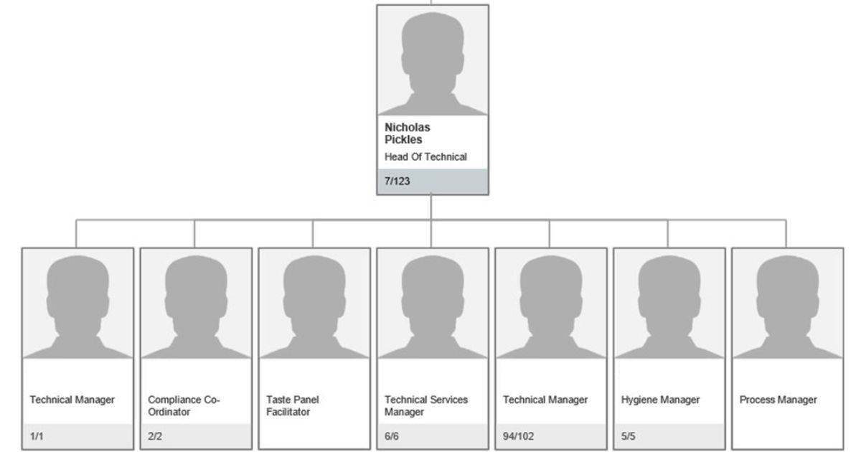

Company Behaviours:
- Accountable: We are all Accountable for our actions, behaviours, performance and decisions.
- Disciplined: We are thorough, dedicated and conscientious.
- Agile: We respond quickly and flexibly to changing environments.
- Respectful: We treat people with courtesy and politeness and listen to understand.
- Transparent: We are open, honest and straightforward.

Main Duties:
- Taking responsibility for the journey of new products from New Product Development (NPD) through to successful production launch, ensuring that product consistency is achieved throughout the entire process
- Ensuring all work meets in-house and customer standards for quality and safety
- Scheduling and managing production line trials and re-evaluations making sure that everything has gone to plan and recording, documenting and filing results of trials.
- Arranging materials for trials and pre-productions.
- Building strong relationships with NPD, Production, Commercial & any other staff involved in the new product launch process.
- Understanding company production processes, site capabilities and ingredient and allergen restrictions. Highlight any potential issues to NPD at the first opportunity.
- Organising and facilitating customer visits for trials, pre-productions and any other process related visits.
- Issuing development recipes to the factory teams in plenty of time for product launch.
- Liaising with purchasing colleagues to ensure that all incoming stock for initial production runs is in place.
- Conducting ongoing investigations into production processes and making recommendations for improvements if necessary.
- Ensuring that operating procedures and specifications are written correctly for each new product and available to relevant staff.
- Supporting initial production runs and being available to trouble shoot and provide expert advice if necessary.
- Responsible for all external site testing (Nutrition / Shelf Life / Cooking Verification / Salt Penetration)
- Undertake any duties as requested by Head Of technical that can be out of the usual remits.

Person Specification: | Where identified* |  | Essential | Desirable
Good IT skills i.e. Word, Excel & PowerPoint |  |  | Y
Full Driving Licence |  |  |  | Y
Good understanding of GMP and HACCP |  |  | Y
CIEH Level 4 award in food safety. |  |  | Y
Proven experience in an NPD/Process Development role |  |  | Y
Former Managerial Experience |  |  | Y
*A = Application | *T = Test/Assessment |  | *I = Interview | *P = Presentation
Other Duties:
The duties and responsibilities in this job description are not exhaustive. The post holder may be required to undertake other duties within the general scope of the post. Any such duties should not substantially change the general character of the post. Duties and responsibilities outside of the general scope of this grade of post will be with the consent of the post holder.

