Role: HR Manager |  | Location: Scunthorpe UKP | Grade: Manager
Department: HR |  | Line Manager: Site Director  Dotted Line Manager: Head of HR | Direct Reports: Yes (HR, Training, Payroll & Recruitment)
Job Purpose:
Drive a positive, customer-focused people environment in which colleagues feel engaged, supported, and empowered to grow and develop to their full potential.
Provide overall leadership and accountability for the People function, ensuring best practice is delivered efficiently and aligned with company objectives.
Lead continuous improvement across all HR systems, software, databases, and KPIs, ensuring robust, data-driven decision-making.
Foster effective and collaborative partnerships with Trade Unions and Colleague Forums, achieving positive outcomes for both colleagues and the business.
Ensure effective systems and processes are in place to recruit, reward, and develop colleagues to the highest achievable standard, while maintaining full compliance and effective budget control.
Collaborate the site Senior Leadership Team, to continually review workforce planning to ensure resourcing is cost-effective, fit for purpose, and supported through targeted recruitment and training.
Work in partnership with the Head of HR and HR Director, to support and lead the alignment and delivery of the People agenda across the organisation.
Job Scope:
Responsible for the Site function as stated above in the location box.
Align with strategic objectives set by Divisional HR.
An active and pivotal member of the Site Senior Leadership Team
Stakeholders & Relationships
It is essential to create positive relationships to gain positive results through collaborative partnerships with:
- Group and Divisional leads
- Senior Leadership Team
- Senior Management Team
- Colleagues
- External bodies

2SFG Behaviours:
Accountability - It’s taking responsibility; carrying the burden; being answerable; knowing the onus is on you; accepting the duty; agreeing it’s your task; showing integrity; being conscientious.
Discipline - It’s showing control; making preparations; following best practice; having direction; being methodical; taking time to plan; complying with regulations.
Agility - It’s being responsive; working at speed; bringing energy; being decisive; making the right call; delegating to others; collaborating when needed
Respect - It’s showing appreciation; treating with dignity; having courtesy; listening to other views; giving credit to others.
Transparency - It’s being very clear; being truthful; being straightforward; being trustworthy; showing sincerity; sharing thoughts and plans

Accountabilities | Responsibilities: |  |  | Knowledge, skills, experience
- Plan and implement the site recruitment strategy using agreed processes  - Input into the annual planning process - advising on most effective staffing structures and timescales with costings for labour, including external labour providers  - A partnered collaborative approach to ‘getting the best’ from Trade Unions  - Take a pro-active approach in advising Directors and Managers on statutory changes and developments in best practice.  - Ensuring compliance with Policies and Procedures  - Create a ‘fit for future’ plan to be future ready with regards to people and processes  - To nurture a customer centric culture that puts the customer at the heart of everything that we do.  - To lead a plan that inspires and engages our people to feel valued and to fulfil their potential  - Strive to be a high performing workforce, achieved through leadership, diversity and recognising individual contributions towards the bigger picture.  - Ensuring we are fit for the future with the best talent in the industry by attracting the best, then "unleashing potential" and continuously developing our people.  - Create a culture whereby people feel safe to offer open honest and constructive feedback  - Developing the People Team to ensure the business is set up for success | - Liaise with external professionals as required.  - Ensure the organisation’s HR policies are developed, updated and reviewed according to our specific needs and following developments in employment law and best practice.  - Convene / attend working groups to ensure that we take account of the people dimension in any initiatives or projects.  - Liaise with the recruitment agency, ensuring documentation is provided in timely manner.  - Shared service staff involved in HR activities  - Recruitment and selection process.  - Colleague personal data is secure and in line with GDPR  - Payroll and benefits are audited and reviewed for best practise  - Absence management is controlled with positive fair processes  - Preparation of staffing statistics to assist in the planning process.  - Site payroll process for both hourly and salaried colleagues  - MyPeople for the development of our people  - Undertake research as required for the annual salary and review process and implement changes agreed  - Drive the design and implement organisational training programs  - Liaise with the FC on any changes to payroll on a monthly basis to ensure compliance  - Liaise with professional development bodies and networks to disseminate opportunities for professional development and training events, taking advantage of funding wherever possible.  - Preparing data for submission and liaising with the survey provider.  - Prepare budgets for staffing related investments, including recruitment, training and development  - Act as project manager for HR initiatives, preparing plans with appropriate milestones and deadlines.  - Support/coach People team to offer the best customer service  - Assist managers in reviewing team structures and provide advice in the management of restructuring, including consultation processes.  - The expert in managing conflicts at work & dispute management  - Work across the organisation to build a learning culture and positive working environment.  - Where appropriate, support initiatives across UKP. |  |  | - 5 years’ experience in Leading a generalist HR team with exposure to all the main HR processes  - A proven People Business Partner  - Minimum CIPD Associate membership and evidence of continuous professional development  - Experience working in FMCG is desirable  - Ability to deliver a responsive customer-centred service, with the ability to negotiate service levels and turnaround times for tasks with Trade Unions and Colleague Forums  - Excellent listening skills with the ability to empathise with others.  - Effective interpersonal, communications and presentation skills.  - Ability to articulate good HR practice in a jargon-free, accessible way.  - Excellent written skills with the ability to draft formal communications which have legal / contractual implications as well as informal internal communications  - Practical knowledge of pay and grading administration issues with ability to use job evaluation and pay benchmarking.  - A good understanding of the operational planning process and ability to spot key HR implications and needs.  - Proven recruitment and selection experience, ideally with good understanding of social media flatform recruitment techniques.  - A good understanding of the principles of a learning organisation and the importance of informal learning as well as formal training and management education.  - Excellent IT skills and competent use of MS Office  - A confident professional with integrity, discretion and the ability to develop trust with staff and managers at all levels.  - Energetic, flexible, responsive and willing to be hands-on where required and committed to providing a service that makes a difference.  - Well organised, with the ability to manage multiple projects and work streams as well as ad hoc responsive tasks, balancing a range of priorities and deadlines
KPIs / Performance Measures

Attendance, Retention, Sustainability, Engagement, Starter and Leaver trends, Development %/£, Recruitment %/£, Agency %/£ - this is not an exhaustive list
Structure fit
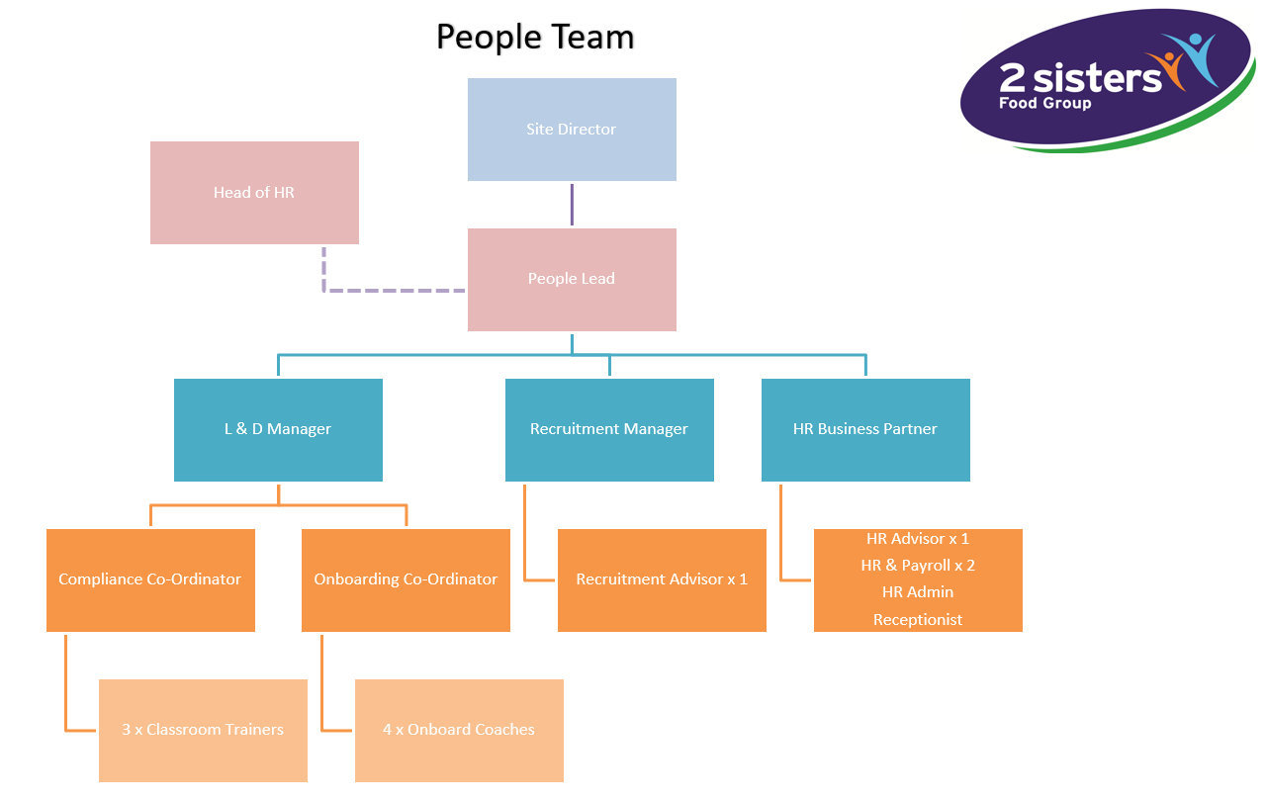

I have read and understand my roles and responsibilities as detailed within this job description.

Name……………………………………………………………………………………Signature………………………………………………………………………………………………

Date………………………………………………………………………………………

